SALESFORCE PROJECT

***Time Capsule App***

**Phase 6: User Interface Development**

**➤ Lightning App Builder**

* Tool to create custom Lightning apps by dragging and dropping components.
* Combine standard components (Related Lists, Highlights Panel) and custom ones (LWC) into a single app view.

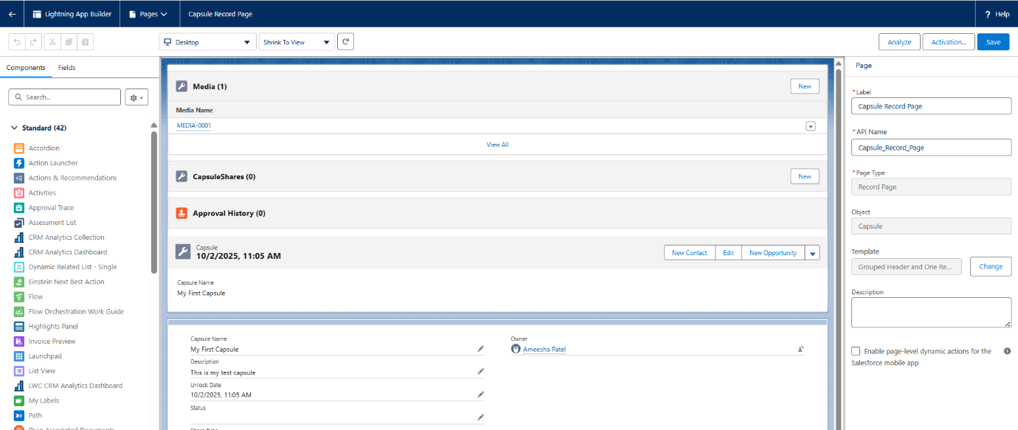

**➤ Record Pages**

* Define how a record looks (fields, tabs, components) when a user opens it.
* Assign different layouts for desktop/mobile or for different profiles.

Example: Capsule__c Record Page → Highlights Panel (Capsule Name, Unlock Date), Related List (Media__c).

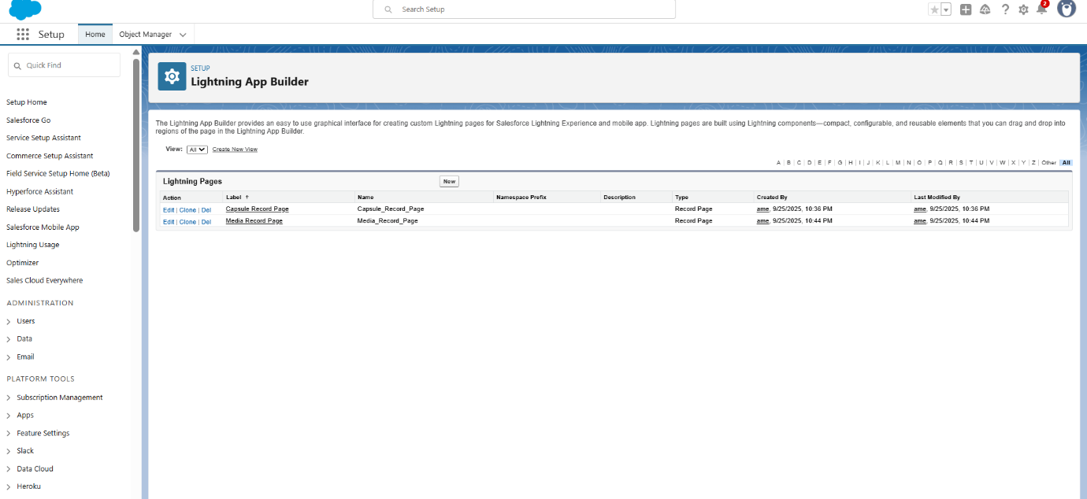

**➤ Tabs**

* Media__c can be made visible with Tabs. Custom objects like Capsule__c and
* Tabs allow users to access those records directly from the navigation bar.

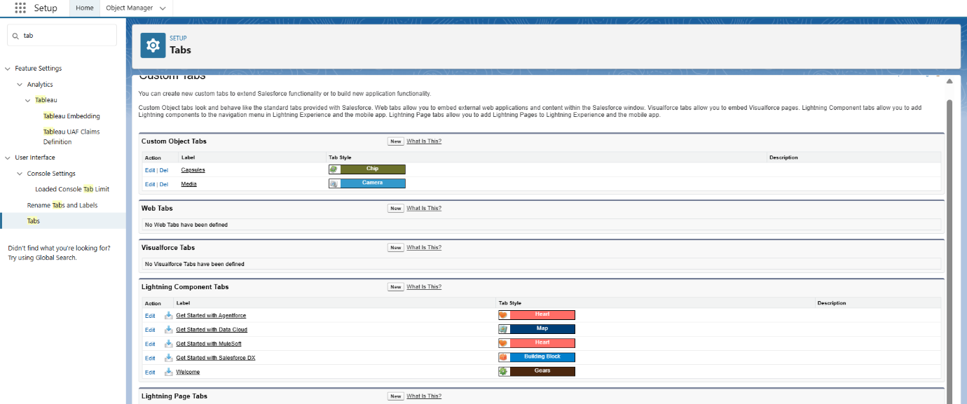

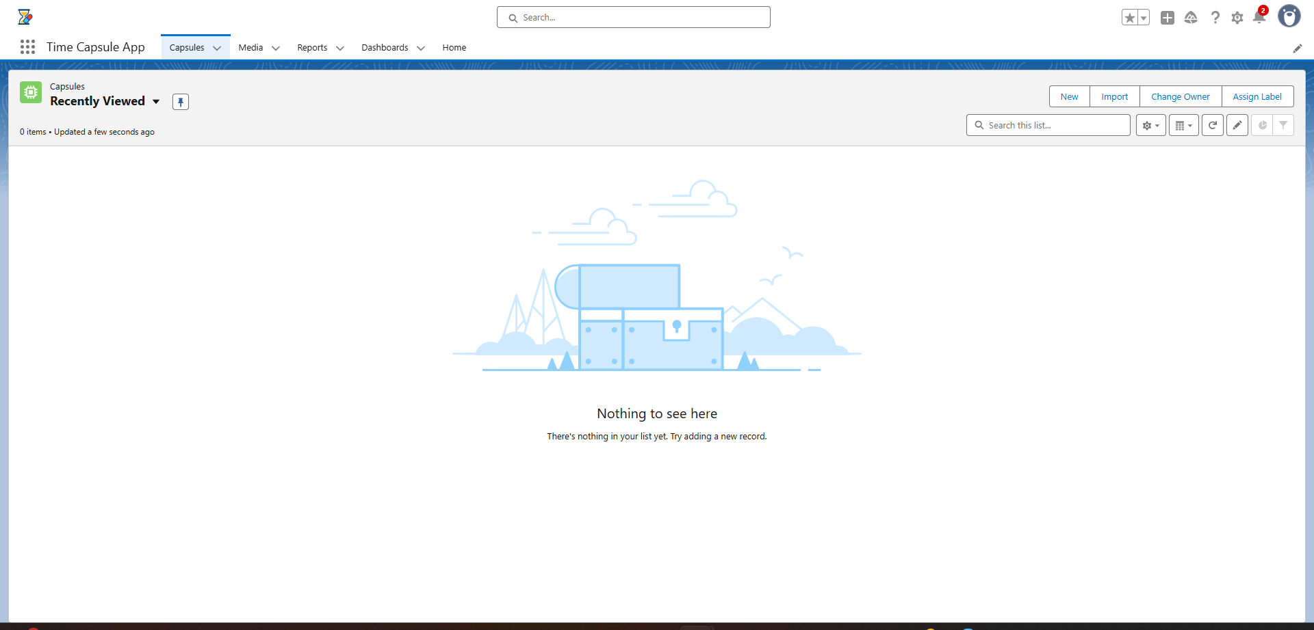

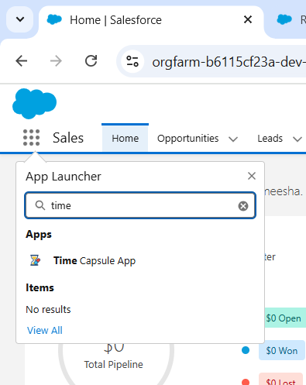

**➤ Home Page Layouts**

* Customize the **Home Page** for different profiles.
* Add components like dashboards, recent capsules, or upcoming unlock dates.

